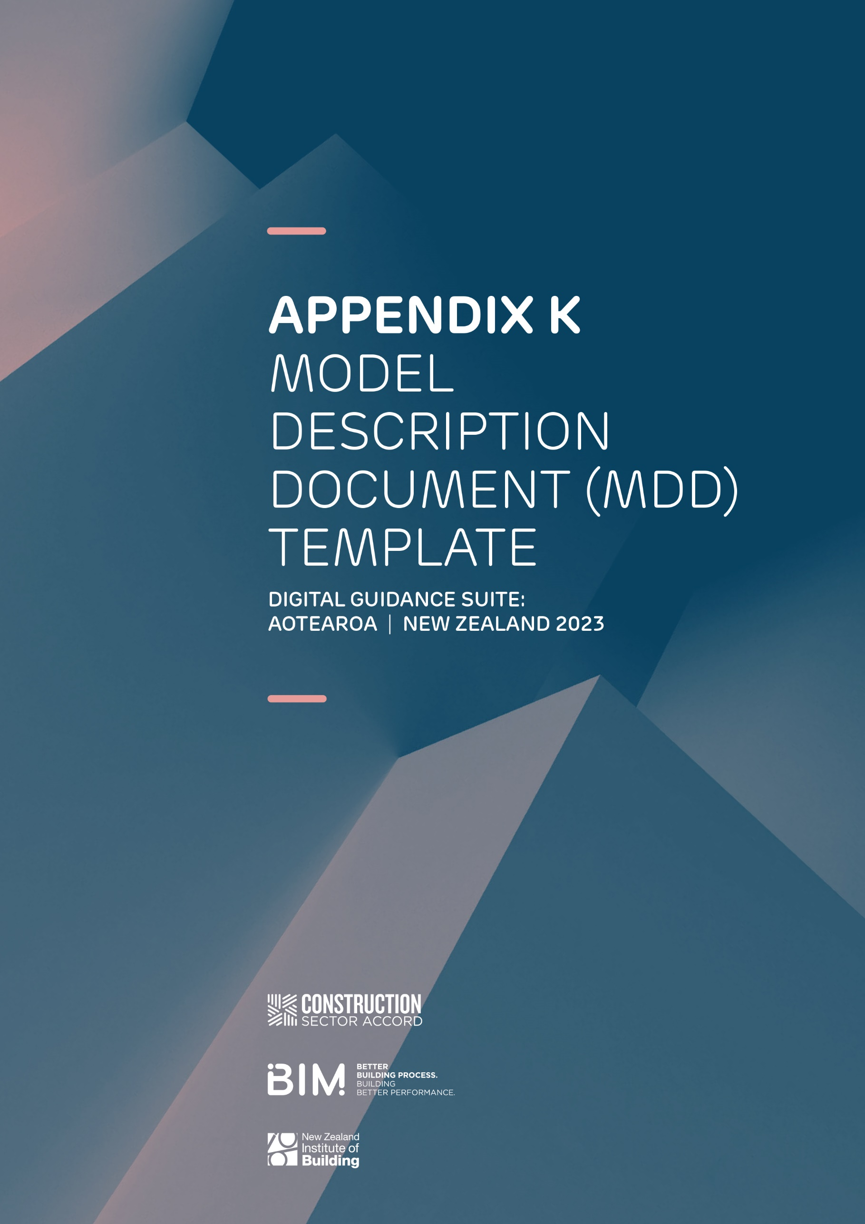

MODEL DESCRIPTION
DOCUMENT - TEMPLATE
A Model Description Document (MDD) is a document issued with a model describing what it contains and identifying limitations of its use.
Exchanging models is the very basis of the BIM process. All users need to understand the levels to which they can rely on the models they receive. Models can contain far more information than traditional electronic deliverables.
The issuer of a model must clearly define what it can be used for and make information available for others to use during the development of the project.

MODEL INFORMATION

Project Name
BIM execution plan reference and revision
Model authoring company
Discipline BIM lead
Native file type and version
Issued file type and version
Issued date
Model status
Model name
File name
Linked files
Inputs
Model purpose
Changes and updates
Areas on hold
Comments

Agreed model use
.

The model has been issued for (delete those that do not apply):
- Aiding coordination during the design process. Only specific areas noted as being complete should be used
- Model elements are to the level of development as agreed in the model element authoring schedule within the BIM execution plan, unless otherwise agreed
- Providing an overall view of the project to supplement the information contained in the drawings and schedules
- A visualisation aid
- Assisting in production schedules of quantities
- Assisting in the production of shop or fabrication drawings
- Input to fabrication, manufacture, and/or construction
- Other project-specific reasons

Notes:
Insert notes here

